Technical Design and Specification

Interferome

Confidential and Proprietary Information
This document contains information that is proprietary to Monash University. Transmittal, receipt, or possession of this document does not express license, or imply rights to use, sell, design, manufacture, or to have manufactured, any product, concept, or service from this information. No reproduction, publication, or disclosure of this information, in whole or in part, electronic or otherwise, shall be made without prior written authorization of an officer of Monash University
Authorized transfer of this document from the custody and control of Monash University constitutes a loan for limited purpose(s), and this document must be returned to Monash University upon request, and in all events, upon completion of the purpose(s) of the loan.

Document Change Log

Prepared By | Module | Date | Version
Russell Sim |  | 10/09/2010 | 1.00

Revisions

Modified By | Reason | Date | Version
Simon Yu | Updating | 12/12/2011 | 1.00

Table of Contents

1. Introduction 4
1.1. Purpose 4
1.2. Scope 4
1.3. Acronyms, Abbreviations, Terms and Definitions 4
2. Design Overview 4
2.1. Architecture Goals and Constraints 4
2.2. Guiding Principles 4
3. Detailed Design 7
4. Components and Processes 8
4.1. BASE 8
4.2. Interferome 8
5. Interfaces 9
5.1. Interferome Import 9
5.2. ARDC 10
6. Security 10
7. Reuse 10
8. Test Plan 10
8.1. Unit testing 10
9. Extensibility 10
10. Nonimplemented tasks 10
11. Summary 10
Appendix A: Acronyms, Abbreviations, Terms and Definitions 11

Introduction

Purpose
The purpose of this document is to outline the technical design of the Interferome bioinformatics database and provide and overview associated systems and interactions.
Its main purpose is to:
- Provide a link between the Functional specifications and the high-level business requirements.
- Detail the functionality that will be provided by each component of group of components and show how the various components interact in the design.
- Provide a basis for the Interferome detailed design and development.
This document is not intended to address installation and configuration details of the actual implementation.

This document is updated and refined based on changes to the requirements.

Other related documents: High Level Business Requirements located at (https://confluence-vre.its.monash.edu.au/display/andsprojects/MIMR+Interferome)

Scope
The Application Design outlined in this document builds upon the scope defined in the Requirements phase.

Acronyms, Abbreviations, Terms and Definitions
Please refer to Appendix A for a list of all acronyms and abbreviations.

Design Overview

Architecture Goals and Constraints
The overall architecture goals of the systems are to provide a robust bioinformatics platform for the MIMR laboratory and ability to register data with the ARDC. The system accomplishes this by extending the existing research workflow using industry standard tools and enhancing the Interferome web interface.

This platform aims to extend the current research workflow to meet the following aims:
- Encourage cataloging of the experimental research data
- Formalise the interfaces used to access the Interferome service
- Enable publication to the ARDC

Guiding Principles
Some of the guiding principles that will be followed during the Interferome design and development are outlined below.

Modular
Modularity is the isolation of complexity and strict definition of interfaces. Throughout this project modularity has been a primary principle due to the complexity and specificity of the research area. Because of this many independent services and tools will need to be leveraged to gain the required result.

Standards Based
Services that comprise Interferome where possible will be standards compliant. Compromises must be made in cases where research tools do not implement a standard but the major components of the Interferome service will be standards compliant and deployed in a standards compliant manner. Examples of standards include XHTML, PEP8, JSR-168, MIAME.

Agile Development
By developing within an agile framework we are able to react quickly to client changes and ensure that the client is involved during the development process.

Detailed Design
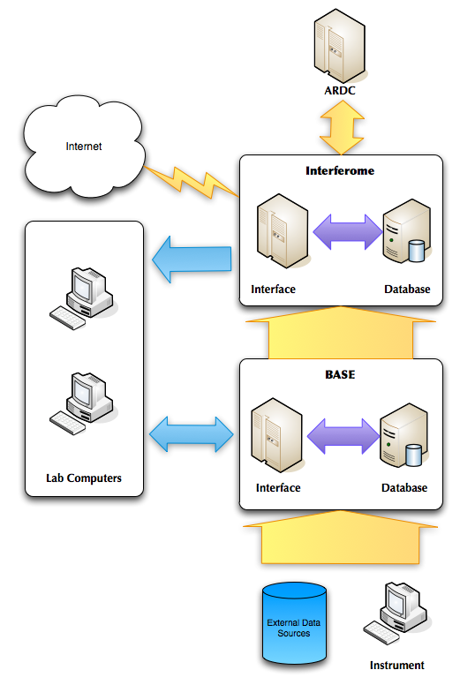
Figure 1
Interactions of the software components along with its responsibilities are expanded below:
Interferome Interface – Interferome service is comprised of 2 major components one of which is the Web accessible interface provides the business logic component of the Interfrome service.

Interferome Database – The Interferome database store all their results from IFN reactions and any other metadata relating to these reactions in a relational form.

BASE Interface – BASE is used to handle microarray experimental results after they have been received from the instruments. BASE is a servelet running within the Apache Tomcat container.

BASE Database – The BASE database is implemented using MySQL and is used to store the experimental results and information required for business decisions.

Instruments – The Agilent Technology microarray scanner is used to process experiments and digitize results. This could be replace by any brand of scanner.

External Data Sources – The MIMR groups has access to some external data sources and data stores that are not in the public domain.

Lab Computers – Researchers within MIMR will need to have access to both BASE and Interferome to allow them to conduct there normal research activities.

Internet – Internet encapsulates external users you might access the Interferome web site.

Components and Processes

BASE

Importing
BASE handles importing research outputs from the Agilent Microarray instrument at MIMR. ArrayExpress, GO

Interferome

Interface
The Interferome web interface provides and interface for anonymous and MIMR users to access data within Interferome. Access is provided using a search interface which the user can enter a list of Ensemble IDs and the Interferome will return a list of matching genes from the database. Searches can also be filtered based on IFN type and species.

BioMART looks to replace the existing web interface of Interferome because of its extended functionality ability to do queries across many data sources. It cannot completely replace the Interferome web interface because of features like importing the BioMART doesn’t support.

ARDC compliant interface that implements OAI-PMH and RIF-CS XML output will also be implemented independent of the BioMART interface.

IFN calculation
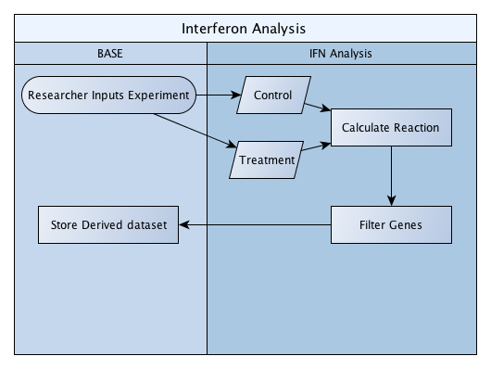
The fold calculation within BASE requires the identification of both a control and treatment datasets. Differences between the two datasets are then measured and the result is filtered to cover only the IFN regulated genes.

This component will be developed as a BASE analysis plugin. These plugins can process bioassays to produce derived bioassays.

Interferome Import

Importing a dataset into Interferome from BASE can only be done where experiments contain IFN derived datasets. This is then inserted into Interferome.

Data imported from BASE also need to clearly identify weather is it public or private because data provided to MIMR by collaborators and other private sources shouldn’t be published though the public interface of Interferome.

Processing and Data Analysis
Interferome data needs to have some processing occur to enable searching and identification of interesting datasets. In this case Miranda, Transfac and Prosite are all used for automated analysis of that data within Interferome. Theses services need to have access to the database and in some cases need to be notified when new data has been entered within Interferome.

Interfaces

Interferome Import
To abstract away form the database Interferome will provide a base import interface so the users can submit data into Interferome.

ARDC
A special ARDC RIF-CS interface will be built onto the Interferome Interface to enable harvesting from the ANDS ARDC harvester. This interface will implement communication using OAI-PMH and will output RIF-CS as the primary export format.

Security
Interferome needs to clearly separate public and private datasets. This access control is implemented within the Interferome Interface and stored within the Interferome Database. Administrators are the only users allowed to modify the permission information. The supported security roles are:
Public – datasets that can be accessed by anonymous users.
Private – datasets that can only be accessed by researchers within MIMR.

Reuse
Can components be put into another university.
BioMART, Interferome Import

Test Plan

Unit testing
The unit testing is a method by which individual units of source code are tested to determine if they are fit for use. JUnit testing framework will be used in unit testing.

Extensibility
Struts2, Hibernate and Spring2 are extensible frameworks for building enterprise-ready java web application. Which makes Interferome more scalable and extensible when a new functionality or modification of existing functionality required.

Nonimplemented tasks
None

Summary
The Interferome is a database of IFN regulated genes published in 2009 (Interferome.org; Samarajiwa et al., Nucleic Acids Res. 37, 852). This represents the initial stages in capture and integration of IFN treated microarray datasets, incorporating over 40 published and internally generated microarray datasets. This approach enables identification of interferon regulated gene sets in many biologically diverse high throughput microarray experiments.

Development work in this period covered the following functionality:
- Integration of BASE (Bio Array Software Environment) and Interferome system
- Implementation of Data Capture Component to import data from Agilent machines, ArrayExpress and GEO to BASE Microarray database
- Transfer of data from BASE to Interferome

- Development of a web interface to provide improved usability and enhanced functionality compared to the legacy system used by the researchers including
- Provision of greater query capability on the underlying research data
- Import of research data consisting of Experiment Metadata, Annotation and Datasets
- Generation of RIF-CS for a data collection record that can then be harvested by ARDC:
- Data Collection metadata registration process to capture the relevant information such as data licensing;
- Integration to the Research Master web services (EIF038) to retrieve the party and activity information for association with the data collection.

Appendix A: Acronyms, Abbreviations, Terms and Definitions

ARDC | Australian Research Data Commons
ANDS | Australian National Data Service
OAI-PMH | Open Archives Initiative – Protocol for Metadata Harvesting
RIF-CS | Registry Interchange Format – Collections and Services

